RTOS Cooperative Scheduler Debugging Guide
This guide documents the RTOS cooperative scheduler context-switch process step by step, based on the uploaded debugging notes. It is intended to help you follow the scheduler in your debugger, understand the memory layout in SRAM, track the Task Control Block (TCB) pointers, and verify how the ARM Cortex-M0+ saves and restores task state during a context switch.

1. Hardware Initialization and Memory Setup
Before the scheduler can switch between tasks, the RTOS must initialize the Task Control Blocks and assign stack space in SRAM. At this stage, Task A is already prepared to run, while Task B may still be waiting for initialization.

1.1 Initial State: Task A Ready, Task B Not Yet Initialized
- `current_tcb` pointer: The current task pointer holds the base address of the TCB list at `0x20000820`. This points to `TCB_LIST[0]`, which represents Task A.
- Task A stack pointer: `TCB_LIST[0].topStackPtr` is initialized to `0x200005DC`, meaning Task A’s stack has already been allocated and is ready for execution.
- Task B stack pointer: `TCB_LIST[1].topStackPtr` is initially `0x0`, which means Task B has not yet been assigned stack space.
- Meaning of this state: The scheduler is still focused on Task A, and only Task A is runnable at this moment.
- 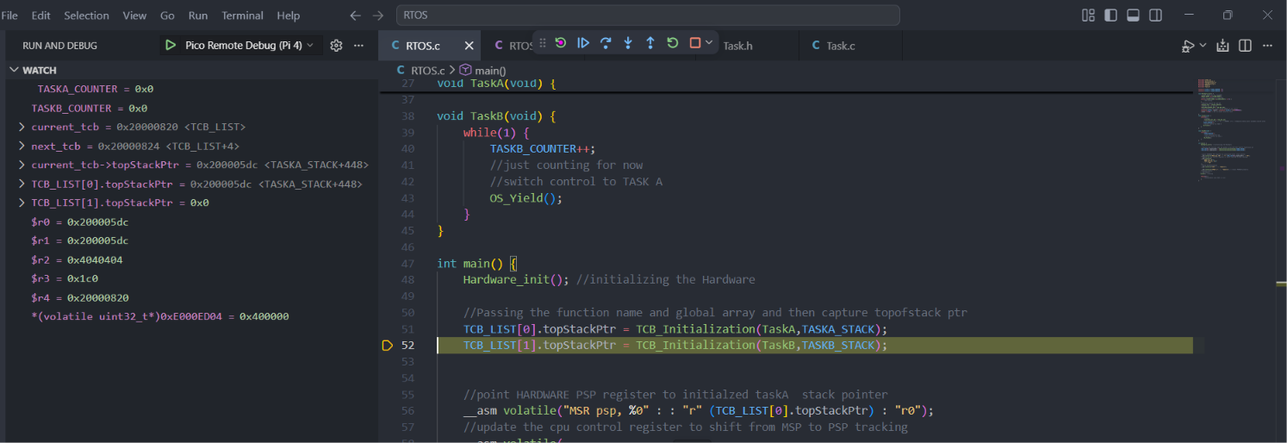

1.2 Post-Initialization State: Both Tasks Ready
Once Task B is initialized, the RTOS assigns it stack memory and prepares a second pointer so that a context switch can occur. At this point, `next_tcb` is introduced, and the system is ready to hand off execution from Task A to Task B.

Pointer Variable Reference Table
Pointer Variable | TCB Address (SRAM) | Target Task | Stack Memory Address | Status
current_tcb | 0x20000820 | TCB_LIST[0] (Task A) | 0x200005DC | Active
next_tcb | 0x20000824 | TCB_LIST[1] (Task B) | 0x20000700 | Queued
Debugging Note: The `next_tcb` value is exactly 4 bytes ahead of `current_tcb` (`0x20000820 + 4 = 0x20000824`). This indicates that the current TCB structure being used in this design occupies 4 bytes for the stored stack-pointer field.
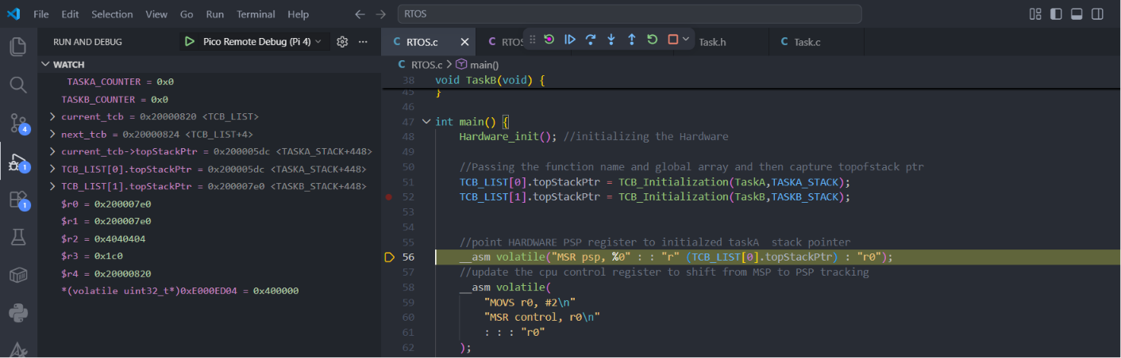
Once it goes in to TASKA function and then it will increment TASKA counter and it will go into OS_Yield function (which is in asm file).
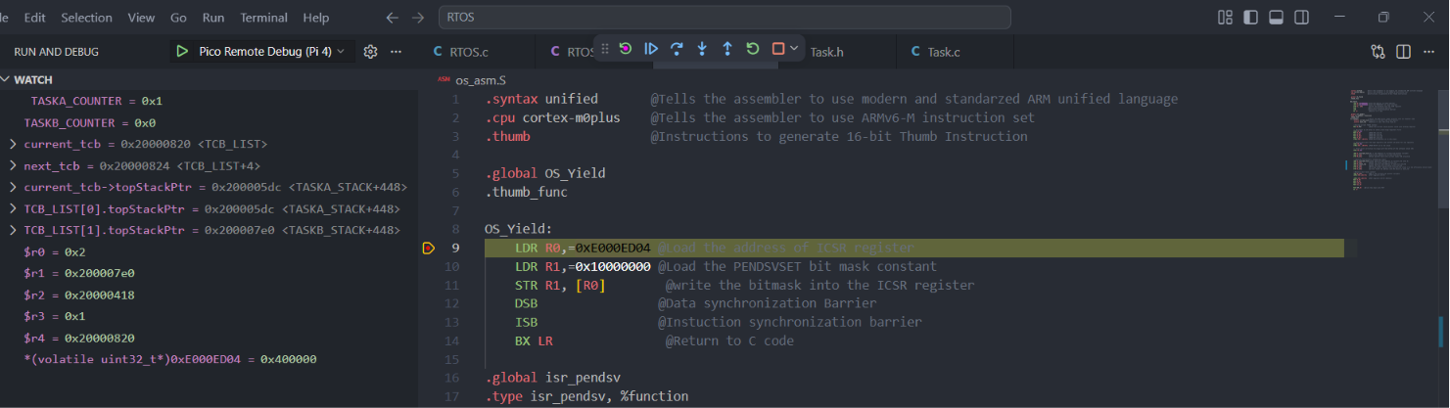

2. Triggering the Context Switch with OS_Yield
When Task A reaches the point where it must give execution time to another task, the RTOS calls `OS_Yield`. This routine does not directly switch tasks by itself. Instead, it requests the PendSV exception, which is the standard Cortex-M mechanism used to perform a deferred context switch safely.
- `LDR R0, =0xE000ED04`: This loads the address of the Interrupt Control and State Register (ICSR) into `R0`. The register address is used as the destination for the upcoming write.
- `LDR R1, =0x10000000`: This loads the `PENDSVSET` bitmask into `R1`. Bit 28 is the control bit that requests the PendSV exception.
- `STR R1, [R0]`: This stores the bitmask into the ICSR register. As a result, PendSV is marked pending and will execute as soon as the processor is ready.
- `DSB`: The Data Synchronization Barrier ensures the store operation has fully completed.
- `ISB`: The Instruction Synchronization Barrier flushes the pipeline so that subsequent execution sees the updated processor state correctly.
- Result: Control now moves toward the PendSV handler, usually named `isr_pendsv`, where the actual context-switch logic begins.
- 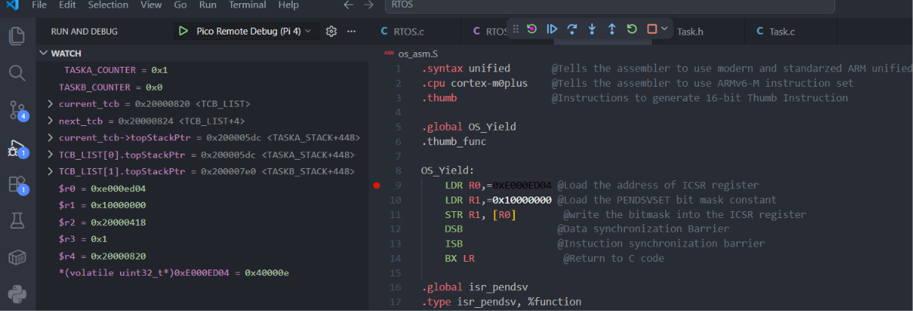

3. Saving Task A Context in PendSV
As soon as the PendSV exception fires, the ARM Cortex-M0+ hardware automatically begins saving part of the current task state. After that automatic save, the software handler completes the rest of the work by preserving the remaining registers and updating the current task’s TCB entry.

3.1 Automatic Hardware Save
- What the CPU saves automatically: The Cortex-M hardware pushes the standard exception frame onto the current task stack. This includes `xPSR`, `PC`, `LR`, `R12`, `R3`, `R2`, `R1`, and `R0`.
- 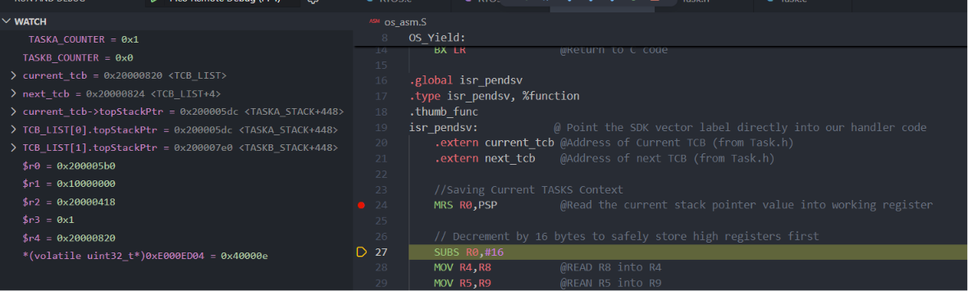
- Total size: 8 registers × 4 bytes = 32 bytes, which is `0x20` in hexadecimal.
- Stack movement: If Task A’s stack pointer was originally `0x200005DC`, then after the hardware push it becomes `0x200005BC`.
- Why the pointer changes: The stack grows downward in memory, so the hardware reduces the Process Stack Pointer before storing the exception frame.

3.2 Manual Software Save of R4-R11
- `MRS R0, PSP`: Read the current Process Stack Pointer into `R0`. After the automatic hardware save, this value is expected to be around `0x200005BC`.
- `SUBS R0, #16`: Decrease the pointer by 16 bytes to make space for the first software-saved register group.
- Move high-register values: Because the Cortex-M0+ instruction set is limited, values for `R8` to `R11` are often temporarily moved into `R4` to `R7` before storing them.
- `STMIA R0!, {R4-R7}`: Store four registers onto the stack. The writeback operator (`!`) increments `R0` after the store.
- `SUBS R0, #32`: Rewind and allocate space again so the second group of saved registers is placed in the correct position. This accounts for both the previous pointer movement and the remaining register storage area.
- `STMIA R0!, {R4-R7}`: Store the second batch of register values.
- `SUBS R0, #16`: Apply a final pointer correction so `R0` points to the bottom of the complete software-saved register block.
- 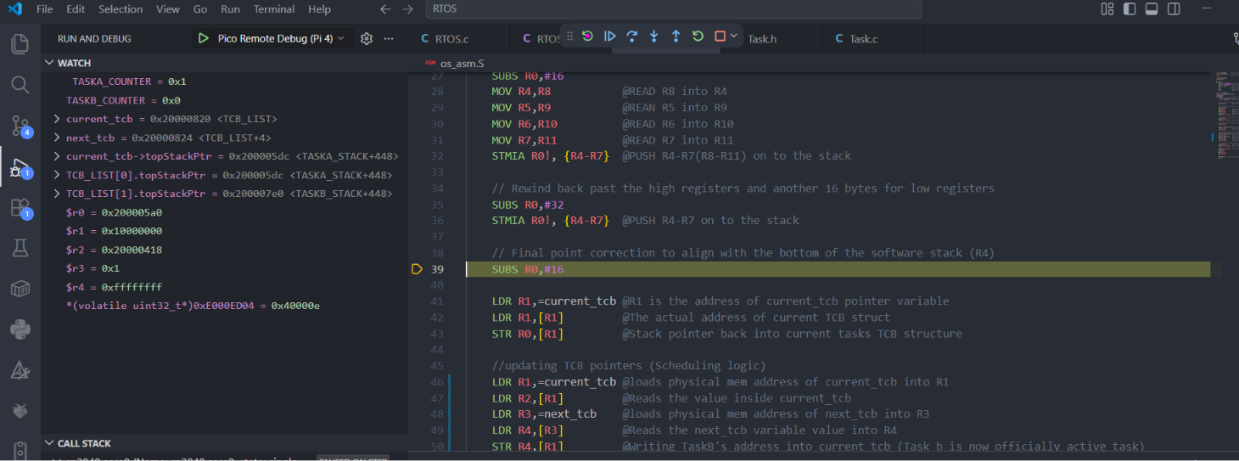
- Load the TCB location: The handler then obtains the address of the `current_tcb` variable, reads the current task’s TCB address, and prepares to write the updated stack pointer back into the TCB.
- `STR R0, [R1]`: Store the final updated stack pointer into the current task’s TCB entry. At this point, Task A’s context is fully saved in SRAM.
- 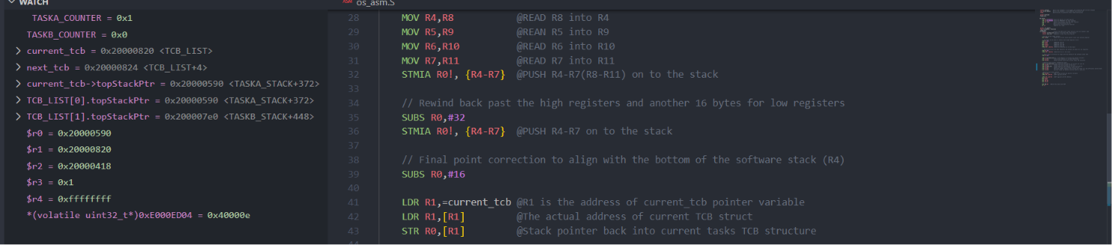

4. Scheduler Pointer Update Logic
Once Task A has been fully saved, the scheduler updates its global bookkeeping pointers. This is the moment when Task B becomes the current task and Task A is moved into the queued position for the next switch.
- `LDR R1, =current_tcb`: Load the memory address of the `current_tcb` variable itself.
- `LDR R2, [R1]`: Read the value stored in `current_tcb`, which is Task A’s TCB address.
- `LDR R3, =next_tcb`: Load the memory address of the `next_tcb` variable.
- `LDR R4, [R3]`: Read the value stored in `next_tcb`, which is Task B’s TCB address.
- `STR R4, [R1]`: Write Task B’s TCB address into `current_tcb`. Task B is now officially the active task.
- `STR R2, [R3]`: Write Task A’s TCB address into `next_tcb`. Task A is now queued to run after Task B.
- 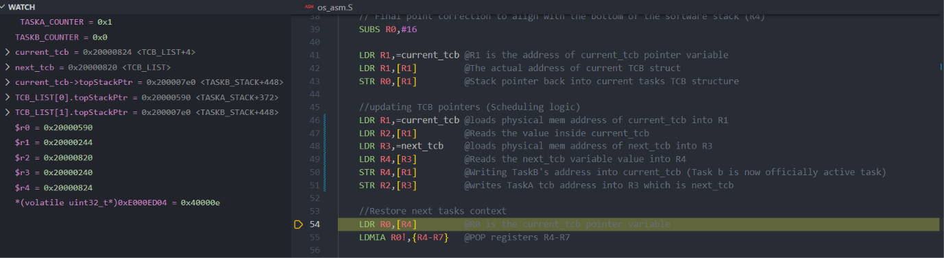

5. Restoring Task B Context
After the pointer swap, the handler begins restoring Task B. The saved stack pointer is loaded from Task B’s TCB, registers are popped back into the processor, and the PSP is updated so that the exception return can resume Task B exactly where it previously stopped.
- `LDR R0, [R4]`: Load Task B’s saved stack pointer from its TCB into `R0`.
- `LDMIA R0!, {R4-R7}`: Pop the first group of saved values from the stack into `R4` to `R7`. The pointer automatically advances upward.
- Move values into high registers: Because the Cortex-M0+ cannot directly restore `R8` to `R11` with a single load-multiple instruction, the values are moved manually from low registers into the high registers.
- `LDMIA R0!, {R4-R7}` again if used in the implementation: Pop the next software-saved register group.
- `MSR PSP, R0`: Write the restored stack pointer back into the hardware Process Stack Pointer register.
- 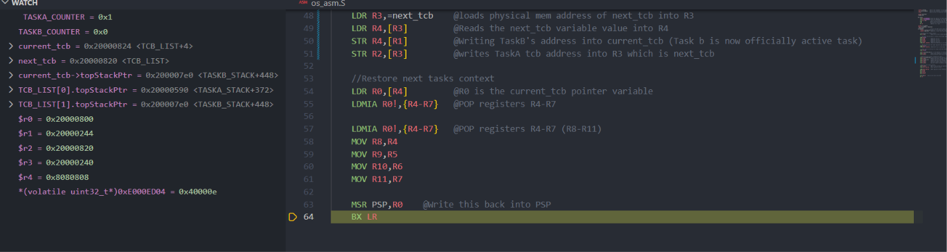
- `BX LR`: Return from the exception. The hardware automatically pops the remaining exception frame registers and resumes Task B at the exact instruction where it left off.

6. Debugger Checklist
- Verify that `current_tcb` initially points to Task A’s TCB.
- Confirm that Task A’s initial stack pointer matches its allocated SRAM region.
- Check that Task B’s TCB is updated from `NULL` to a valid stack address after initialization.
- Step through `OS_Yield` and confirm that the PendSV bit is written into the ICSR register.
- When PendSV begins, verify that the PSP has already moved downward because of the automatic exception frame push.
- Confirm that the software-saved register block is stored correctly and that the final stack pointer is written back into Task A’s TCB.
- Verify that `current_tcb` and `next_tcb` are swapped correctly.
- Check that Task B’s saved stack pointer is loaded and that the PSP is restored before `BX LR` executes.
- After exception return, confirm that Task B resumes execution from its saved state.
This document is designed to serve as a primary step-by-step reference while you debug the cooperative scheduler in VS Code. If you add screenshots or memory diagrams later, they can be placed under the matching sections to make the guide even easier to follow.

